Omar Iqbal

Preface: ***IN ORDER TO RUN THIS PROGRAM, PYTHON, BOTO3, AND AMAZONS CLI MUST BE INSTALLED.***

This program connects to the users AWS account via the Amazon CLI then allows the creation of buckets and storage of items within the buckets.

In order to get to the console, you must go to the directory in which the file exists:

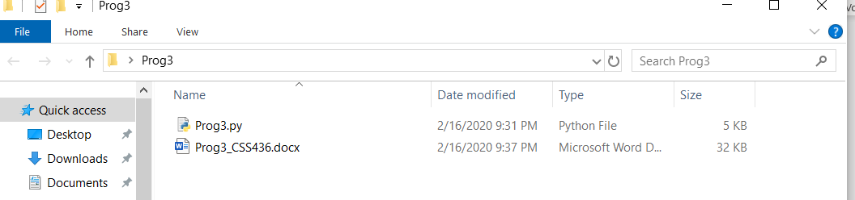

You must then open the cmd like so:

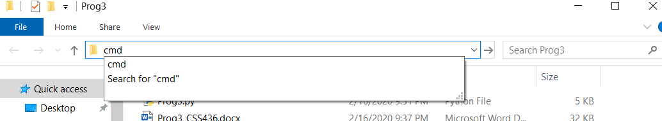

To run the program, it must be accessed from the command line interface starting with the word “python” followed by the program name “Prog3.py” and the directory that is to be interacted with must be passed in as an argument like so:



It will then prompt the user and ask them whether they want to backup the specified local directory or restore to the local directory:



If the user decides to backup, the entire directory including files and folders will then be moved to a specified s3 bucket. If the user decides to restore, everything from a pre-existing bucket will be moved into the directory.



If the user wants to create a new bucket, they must input a valid bucket name to create. If an invalid name is input, the program will re-ask the user to input a valid bucket name (one that has not been taken already, one that is all lower case, etc.). If the user wants to backup or restore from a preexisting bucket, it asks the user to input the name of a bucket that already exists. If a name of a bucket is inputted and the bucket does not exist, the program will end.

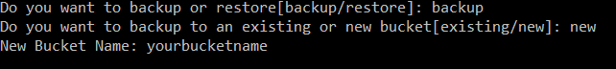

**Arch and Design of Program**

The program starts by entering the promptUser method where all the prompts for the user are kept. Within the prompt user there are calls to the backup and restore methods which handle backing up directories to s3 and restoring files from s3.

Within the backup method, a check is made to improve optimization where when uploading of files to a bucket is occurring, it checks to make sure the files that are being backed up are new. If the files are different than the files stored on the bucket, it will replace the newer, modified files while keeping the unmodified files the same to avoid needless replacements of files that are the same.

When a call to restore items from a bucket is made, all the items in a bucket will be moved into the specified directory. If there are already items in the directory, they will NOT be replaced but rather they will be appended. If the user tries to restore files from the bucket into a directory that already has all the files, the local files WILL be overwritten.

If the specified path that is passed in as an argument is not a valid local directory, a message will be displayed, and the program will exit.